Cancer Translational Research Informatics Platform (caTRIP) Use Cases

DOCUMENT REVISION HISTORY
Version Number | Date | Description
1.0 | May 31, 2006 | - Initial Draft
2.0 | June 16, 2006 | - Added more use cases
3.0 | 7/5/2006 | - Added high-level scientific use cases

Background/Summary
This document presents use cases for the Cancer Translational Research Informatics (caTRIP) system developed by Duke University. Principle features of that system will provide the following functionality:
- Ability to build queries graphically
- Issue one query to many services
- Save, edit and delete queries
- Export query results
- Automatically locate classes across services which are semantically equivalent
- Automatically locate all classes which have direct links to a selected class

We also define high-level scientific use cases that describe the types of data that the user will be accessing, which includes:
- Tissue Bank
- Pathology
- Clinical
- Basic science

Finally, we define specific scientific use cases that describe the actual scientific problems that the system will address. These will be added in the final use case document.

Table of Content
Cancer Translational Research Informatics Platform (caTRIP) Use Cases 1
Background/Summary 1
1 Introduction 3
1.1 Overview 3
1.2 Related Documents 3
2 Actors and Goals 3
3 System Use Cases 3
3.1 Login 3
3.1.1 Use Case Model 3
3.1.2 Brief Description 3
3.1.3 Primary Actor 3
3.1.4 Secondary Actors 3
3.1.5 Preconditions 3
3.1.6 Basic Flow of Events 3
3.1.7 Alternative Flows 3
3.1.7.1 No index service configured 3
3.1.7.2 No IDP configured 3
3.1.7.3 Invalid Credentials 3
3.1.7.4 Expired Password 3
3.1.8 Postconditions 3
3.1.9 Special Requirements 3
3.2 Manage Query 3
3.2.1 Use Case Model 3
3.2.2 Brief Description 3
3.2.3 Primary Actor 3
3.2.4 Secondary Actors 3
3.2.5 Preconditions 3
3.2.6 Basic Flow of Events 3
3.2.7 Alternative Flows 3
3.2.7.1 Save a Query 3
3.2.7.2 Delete a Query 3
3.2.7.3 Update a Query 3
3.2.8 Postconditions 3
3.2.9 Special Requirements 3
3.3 Find Semantically Equivalent Classes 3
3.3.1 Use Case Model 3
3.3.2 Brief Description 3
3.3.3 Primary Actor 3
3.3.4 Secondary Actors 3
3.3.5 Preconditions 3
3.3.6 Basic Flow of Events 3
3.3.7 Alternative Flows 3
3.3.8 Postconditions 3
3.3.9 Special Requirements 3
3.4 Find Associated Domain Classes 3
3.4.1 Use Case Model 3
3.4.2 Brief Description 3
3.4.3 Primary Actor 3
3.4.4 Secondary Actors 3
3.4.5 Preconditions 3
3.4.6 Basic Flow of Events 3
3.4.7 Alternative Flows 3
3.4.8 Postconditions 3
3.4.9 Special Requirements 3
3.5 Manage Search Engine Service 3
3.5.1 Use Case Model 3
3.5.2 Brief Description 3
3.5.3 Primary Actor 3
3.5.4 Secondary Actors 3
3.5.5 Preconditions 3
3.5.6 Basic Flow of Events 3
3.5.7 Alternative Flows 3
3.5.7.1 Manually add a search engine service 3
3.5.7.2 Remove a search engine service 3
3.5.7.3 Indicate a default search service 3
3.5.8 Postconditions 3
3.5.9 Special Requirements 3
3.6 Manage User Preferences 3
3.6.1 Use Case Model 3
3.6.2 Brief Description 3
3.6.3 Primary Actor 3
3.6.4 Secondary Actors 3
3.6.5 Preconditions 3
3.6.6 Basic Flow of Events 3
3.6.7 Postconditions 3
3.6.8 Special Requirements 3
3.7 Manage Query Results 3
3.7.1 Use Case Model 3
3.7.2 Brief Description 3
3.7.3 Primary Actor 3
3.7.4 Secondary Actors 3
3.7.5 Preconditions 3
3.7.6 Basic Flow of Events 3
3.7.7 Alternate Flow 3
3.7.7.1 Download query results 3
3.7.8 Postconditions 3
3.7.9 Special Requirements 3
3.8 Manage Multiple Queries 3
3.8.1 Use Case Model 3
3.8.2 Brief Description 3
3.8.3 Primary Actor 3
3.8.4 Secondary Actors 3
3.8.5 Preconditions 3
3.8.6 Basic Flow of Events 3
3.8.7 Alternate Flow 3
3.8.8 Postconditions 3
3.8.9 Special Requirements 3
4 High-level Scientific Use Cases 3
4.1 Query tissue bank data 3
4.1.1 Use Case Model 3
4.1.2 Brief Description 3
4.1.3 Primary Actor 3
4.1.4 Secondary Actors 3
4.1.5 Preconditions 3
4.1.6 Basic Flow of Events 3
4.1.7 Alternate Flow 3
4.1.8 Postconditions 3
4.1.9 Special Requirements 3
4.2 Query pathology data 3
4.2.1 Use Case Model 3
4.2.2 Brief Description 3
4.2.3 Primary Actor 3
4.2.4 Secondary Actors 3
4.2.5 Preconditions 3
4.2.6 Basic Flow of Events 3
4.2.7 Alternate Flow 3
4.2.8 Postconditions 3
4.2.9 Special Requirements 3
4.3 Query clinical data 3
4.3.1 Use Case Model 3
4.3.2 Brief Description 3
4.3.3 Primary Actor 3
4.3.4 Secondary Actors 3
4.3.5 Preconditions 3
4.3.6 Basic Flow of Events 3
4.3.7 Alternate Flow 3
4.3.8 Postconditions 3
4.3.9 Special Requirements 3
4.4 Query basic science data 3
4.4.1 Use Case Model 3
4.4.2 Brief Description 3
4.4.3 Primary Actor 3
4.4.4 Secondary Actors 3
4.4.5 Preconditions 3
4.4.6 Basic Flow of Events 3
4.4.7 Alternate Flow 3
4.4.8 Postconditions 3
4.4.9 Special Requirements 3
5 Detailed Scientific Use Cases 3
6 Overall Requirements 3
6.1 System Requirements Prioritization 3
6.2 High-level Scientific Requirements Prioritization 3
6.3 Detailed Scientific Requirements Prioritization 3
7 Data Definitions 3
8 Sign Off 3
8.1 Approval 3

Introduction

Overview
The Duke Comprehensive Cancer Center, in collaboration with SemanticBits LLC, has been tasked with developing a translational research system for the Cancer Biomedical Informatics Grid (caBIG) project. The project, which is slated to last for one year, will be divided into two phases. In phase one, Duke will be developing a pilot infrastructure to tackle the difficult problem of outcomes analysis, where a clinician can access clinical, pathology, and basic science data from a cohort of patients to help guide the clinician in determining the best diagnostic and/or treatment modality for new patients. The infrastructure will be composed of a set of caBIG systems, some of which are already deployed at Duke and include C3D, caTIES, caTissue CORE, caArray, and RProteomics. These distributed data systems will be tied together using the caGrid technology developed as part of the caBIG project, leveraging open standards such as the Open Grid Services Infrastructure (OGSI), Globus, XML, and data standards. The project will use existing datasets at the CALGB, Breast SPORE, and others within the Duke research community stored in the eBrowser, Decision Support Repository (DSR), and Medical Assistant on the World Wide Web (MAW3). Phase two of the contract will involve moving the pilot system to a production system that can be deployed and used at other cancer centers.

Related Documents
All project documents are at http://cabigcvs.nci.nih.gov/viewcvs/viewcvs.cgi/catrip/

Actors and Goals
The likely users of the Cancer Translational Research Informatics Platform (caTRIP) system are people with the job responsibilities listed below.
- Registered User – These individuals play the central role in the system. Data access for all user roles will be read only deidentified data. This indicates that a clinician, basic researcher and data tech. (from SRS) have same access and privileges. Pl. confirm. All user have access to query other applications but is the target application which controls what type of data each user can view. Each user must have an account in the Duke Identity Provider.
Would there be any other role i.e Admin/super user who can see identified (internal) data? No
Also, is there any quals needed for a registered user?

System Use Cases
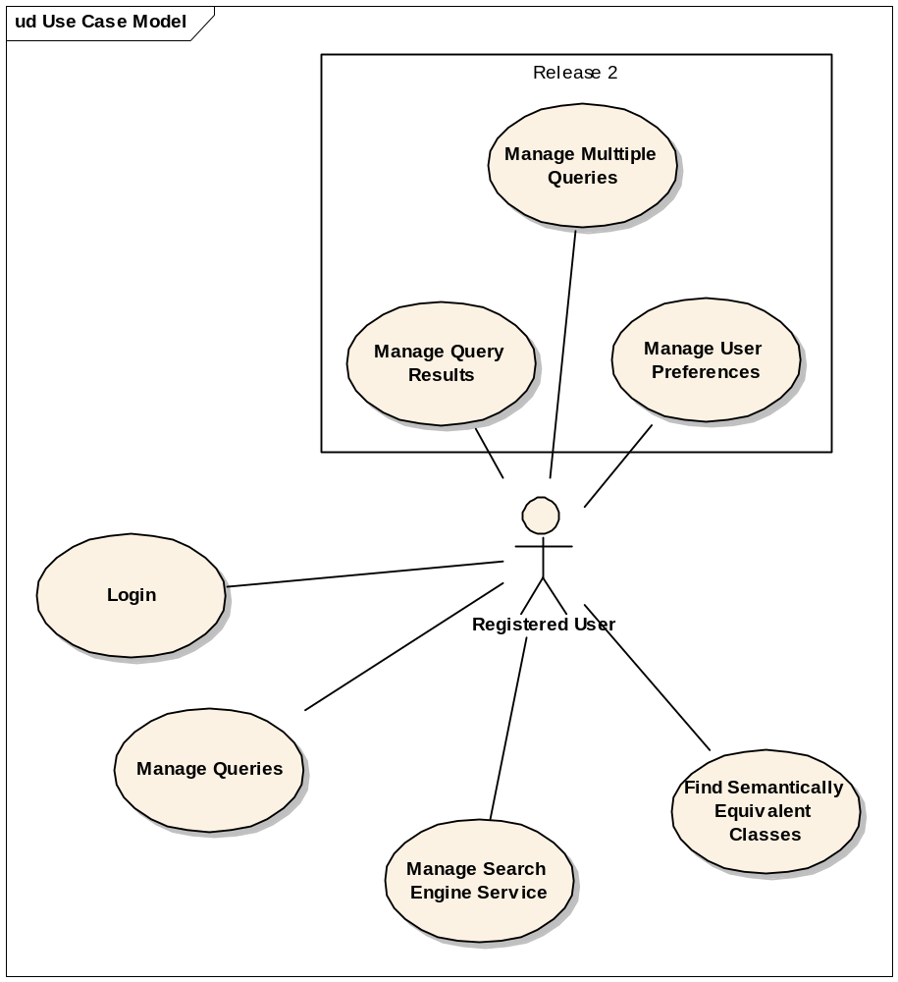

Login

Use Case Model
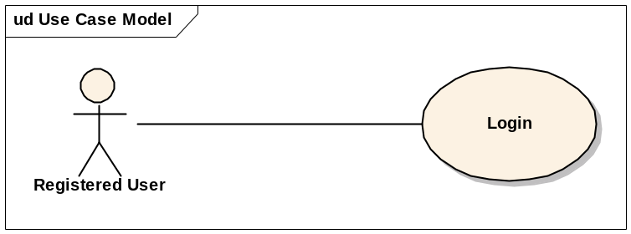

Brief Description
In this use case a user logs into the system
How will a user create an account? Explained in Section 2

Primary Actor
Registered User

Secondary Actors
None

Preconditions
User must have the correct URL.
Valid login credentials, correct url, etc.(this is not a precondition)

Basic Flow of Events
- The system presents a login screen that includes fields for username, password and for selecting an Identify Provider (IDP). What is IDP? Pl. refer if in this/other doc.
- The User provides his username, password and IDP
- caTRIP successfully authenticates the user with the provided credentials.
- caTRIP grants access to the system.

- Alternative Flows

No index service configured
- Before presenting the login screen, the system detects no index service configured
- The system will present an Index Service screen with one field for the index service URL
- The user enters the index service URL(provided by your system administrator) – where does the user get the URL?
- The system presents the login screen
- Continue from step 2 of the basic flow

No IDP configured
- Before presenting the login screen, the system detects that there is no IDP configured.
- The system will present an IDP screen with one field for the IDP URL.
- The user enters the IDP URL (provided by your system administrator) – where does the user get the URL?
- The system presents the login screen
- Continue from step 2 of the basic flow

Invalid Credentials
- This use case flow of events starts at Step 3 of the Basic Flow if the system indicates that the login or password provided is invalid.
- caTRIP presents the login screen again and displays a message that the login credentials were invalid. caTRIP directs the user to contact the system administrator for support if he has problems connecting to caTRIP.

Postconditions
None

Special Requirements
None

Manage Query

Use Case Model
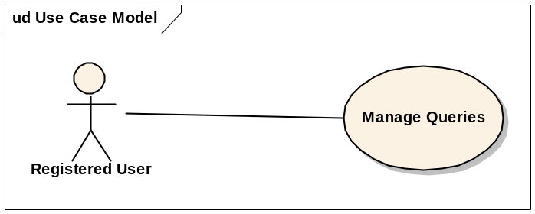

Brief Description
In this use case, a user has the ability to run, create, edit, delete and save queries.

Primary Actor
Registered User

Secondary Actors
None

Preconditions
User is logged in

Basic Flow of Events
- The user creates a query.
- The user selects to submit the query.
- The system will query the available systems
- The system returns the data in a tabular format.

Alternative Flows

Save a Query
- This use case flow of events starts at Step 4 of the Basic Flow when the user wants to save the query
- The system will prompt the user to save a new query or perform a Save As on an existing query.
- User names the query and saves it
- The system will save the query with the given name.
3.2.7.2 – open/execute a saved query?

Open a Saved Query
User navigates to select a query screen
User selects a query
The system opens the query

Delete a Query
- User navigates to the delete query screen
- The system displays a list of saved queries
- The user selects the query to be deleted
- The system prompts for confirmation
- The user accepts and the query is removed from the system.

Update a Query
- The system presents the user with a query selection screen
- The user selects a query to update.
- The system load the query into the query editing screen displaying the query and the services it will query against.
- The user makes a change
- See alternate flow Save a Query

Postconditions
None

Special Requirements
None

Find Semantically Equivalent Classes Locate Equilavent Classes(as worded, this use case seems pretty “technical” for a scientific end user)

Use Case Model (should the Use Case Model shown in Section 3.4.1 be here?)
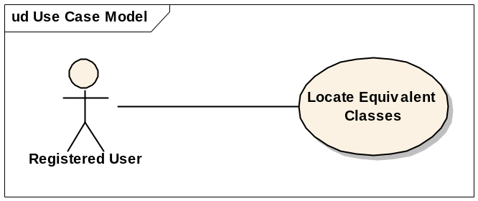

Brief Description
In this use case, a user selects to find all the semantically equivalent classes across services. A user would execute this use case to have the system find equivalent classed in other services. For example, one service may have a patient class and another has a participant class. The two are named differently but they are semantically equivalent.

Primary Actor
Registered User

Secondary Actors
None

Preconditions
User is logged in.

Basic Flow of Events
- User selects a source class for which to find all of its semantically equivalent classes
- The System will display a list of matching classes
- User selects one of the semantically equivalent classes
- The system will display the CDEs for the selected class
- The user will select one CDE from the source class and one CDE from the semantically equivalent class.
- The user accepts the selections.
- The system displays a graphical representation of the classes and link.

Alternative Flows

Postconditions
None

Special Requirements
None

Find Associated Classes

Use Case Model
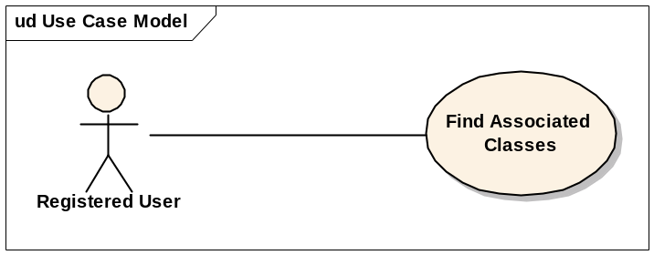

Brief Description
In this use case, a user selects to find all associated classes within a selected service. A user would execute this use case to find all the classes which have a direct relationship with a selected class (this also seems pretty technical for a scientific end user).

Primary Actor
Registered User

Secondary Actors
None

Preconditions
User is logged in.

Basic Flow of Events
- User chooses to find all the domain classes for a selected class (service?).
- The system display a list of matching classes
- The user chooses one or more of the classes and selects ok.
- The system displays the selected domain model class(es) together with the links to the source class.

Alternative Flows

Postconditions
None

Special Requirements
None

Manage Search Engine Service

Use Case Model
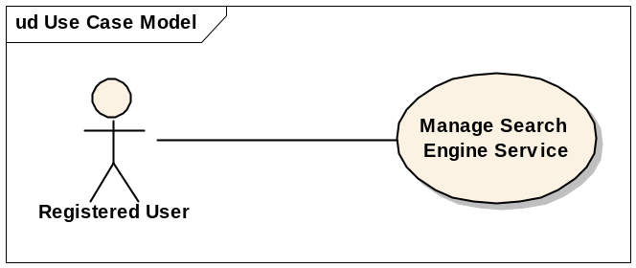

Brief Description
In this use case, a user can view, add and remove search engine services (what is a search engine service in the context of caTRIP?).

Primary Actor
Registered User

Secondary Actors
None

Preconditions
User is logged in.

Basic Flow of Events
- The user chooses to view the list of search engine services.
- The system displays the services

Alternative Flows

Manually add a search engine service
- User selects to add a service
- User enters the URL of the service and a unique service name
- User selects save.
- The system will locate the new service and add it to the list of search engine services.

Remove a search engine service
- This use case flow of events starts at Step 2 of the Basic Flow
- User selects a service(s) to remove and saves
- The system deletes the service(s).

Indicate a default search service
- This use case flow of events starts at Step 2 of the Basic Flow
- The user indicates the default service and presses save.
- The system saves the information.
- This use case flow of events starts at Step 2 of the Basic Flow

Postconditions
None

Special Requirements
None

Manage User Preferences

Use Case Model
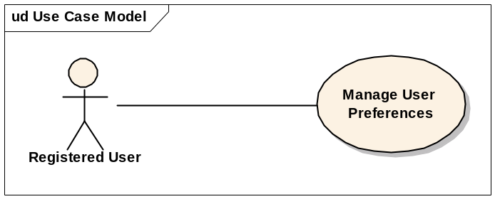

Brief Description
In this use case, a user can view and edit user preferences.

Primary Actor
Registered User

Secondary Actors
None

Preconditions
User is logged in.

Basic Flow of Events
- The user chooses to view his current user preferences.
- The system displays the user preferences
- The user edits the preferences and presses save
- The system stores the changes

Postconditions
None

Special Requirements
The user will have the ability to edit the following:
- Reuse a set of services upon login
- Specify Default Search engine
- Specify folder for query download
- Remember userid and password

Manage Query Results

Use Case Model
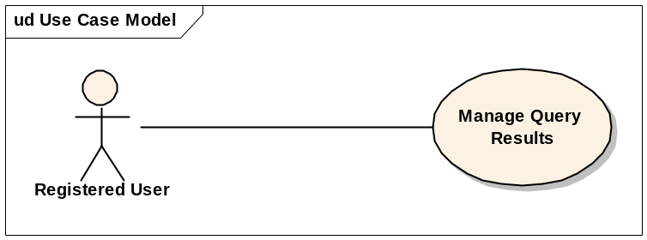

Brief Description
In this use case, a user can choose to send the query results via alternate methods.

Primary Actor
Registered User

Secondary Actors
None

Preconditions
  - User is logged in.
  - Has results from a submitted query
  - Has a valid email client Should this be ‘valid’ email? If compatible, pl. list special requirements in SRS.

Basic Flow of Events
- The user selects to email the query results.
- The user enters the email address and presses send.
- The system exports the results (see 3.3.7.1 Export Query Result).
- The system opens the client’s email program and enters the email address and attaches the results

Alternate Flow

Download query results
- The user selects to download the results in a Comma Separated (comma separated?) format.
- The system will prompt the user to begin the download.
- The user accepts the download process and saves the file to the computer.

Postconditions
None

Special Requirements
None

Manage Multiple Queries

Use Case Model
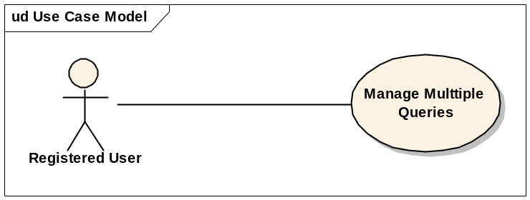

Brief Description
In this use case, a user can open and execute more that one query simultaneous. Per SRS this is listed as ‘Out of scope’ (sect. 1.3.2) pl. validate and include ‘in-scope’ as appropriate.

Primary Actor
Registered User

Secondary Actors
None

Preconditions
User is logged.
User already has one query running

Basic Flow of Events
- The user selects to open a second query.
- The user submits the query
- The user selects to view the progress of each query.
- The system displays the current query statuses.
- The system notifies the user when each query completes
- Each query result is opened in a separate area.

Alternate Flow
None

Postconditions
None

Special Requirements
None

High-level Scientific Use Cases
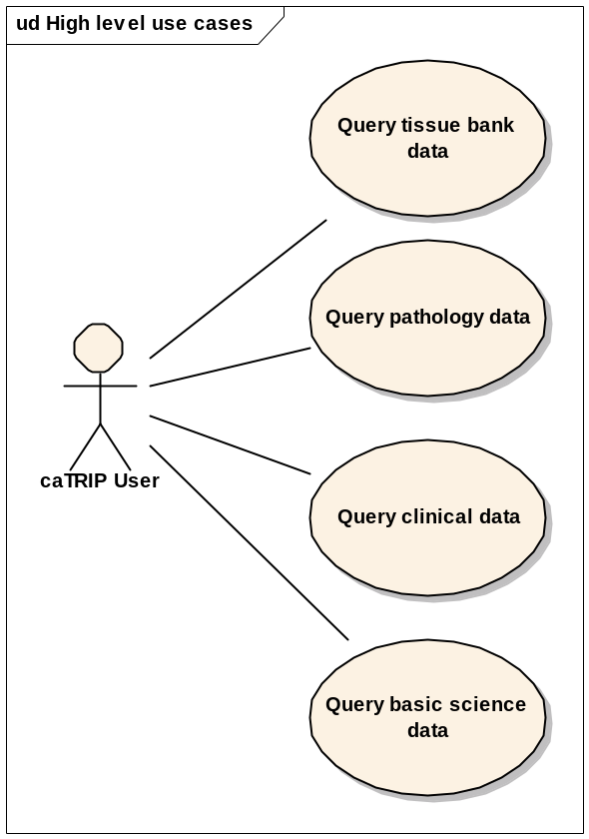

Query tissue bank data

Use Case Model
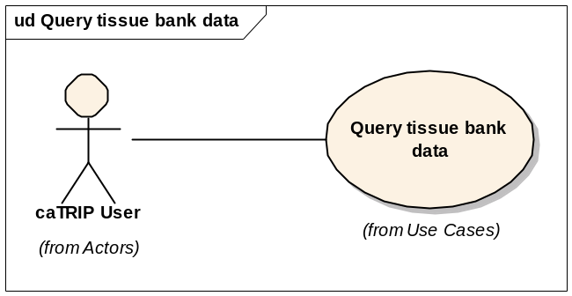

Brief Description
In this use case, a user can query tissue banking data. This will access one or more caTissue CORE grid services.

Primary Actor
Registered User

Secondary Actors
None

Preconditions
User is logged.

Basic Flow of Events
  - The user discovers a grid service that exposes tissue banking data
  - The user constructs a query
  - The user submits the query
  - The user gets tissue banking data back in the form of a report

Alternate Flow
None

Postconditions
None

Special Requirements
None

Query pathology data

Use Case Model
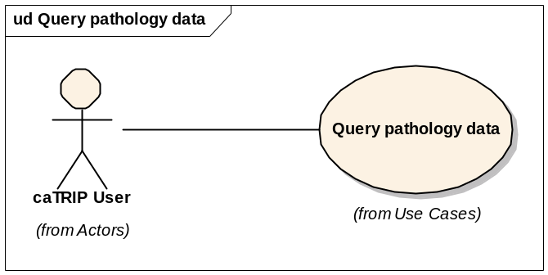

Brief Description
In this use case, a user can query pathology data. This will access one or more caTIES and CAE grid services.

Primary Actor
Registered User

Secondary Actors
None

Preconditions
User is logged.

Basic Flow of Events
  - The user discovers a grid service that exposes pathology data
  - The user constructs a query
  - The user submits the query
  - The user gets pathology data back in the form of a report

Alternate Flow
None

Postconditions
None

Special Requirements
None

Query clinical data

Use Case Model
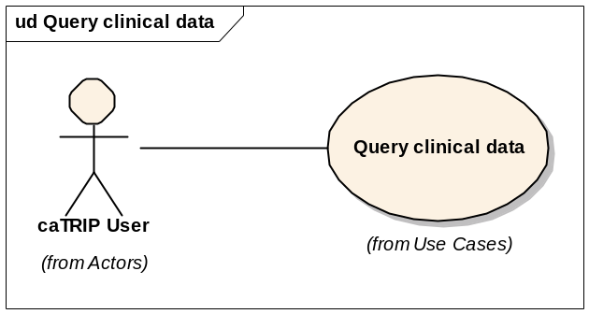

Brief Description
In this use case, a user can query clinical data. This will access one or more CTOM grid services

Primary Actor
Registered User

Secondary Actors
None

Preconditions
User is logged.

Basic Flow of Events
  - The user discovers a grid service that exposes clinical data
  - The user constructs a query
  - The user submits the query
  - The user gets clinical data back in the form of a report

Alternate Flow
None

Postconditions
None

Special Requirements
None

Query basic science data

Use Case Model
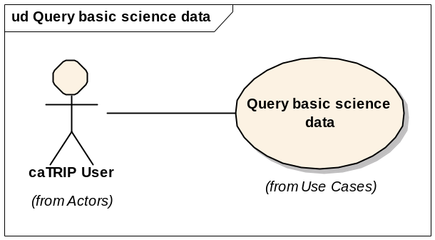

Brief Description
In this use case, a user can query basic science data. This will access one or more caIntegrator grid services.

Primary Actor
Registered User

Secondary Actors
None

Preconditions
User is logged.

Basic Flow of Events
  - The user discovers a grid service that exposes basic science data
  - The user constructs a query
  - The user submits the query
  - The user gets basic science data back in the form of a report

Alternate Flow
None

Postconditions
None

Special Requirements
None

Detailed Scientific Use Cases
This section will be detailed in the Final Requirements and Specifications (Use Case?) document. It will contain fine-grained use cases that describe specific scientific problems that will be solved by the caTRIP system.

Overall Requirements

System Requirements Prioritization

Priority | Use Case Name | Supp Requirement Ref #
1 | Login
1 | Manage Query
1 | Find Semantically Equivalent Classes
1 | Find Associated Domain Classes
1 | Manage Search Engine Service
2 | Manage User Preferences
2 | Manage Query Results
2 | Manage Multiple Queries

High-level Scientific Requirements Prioritization

Priority | Use Case Name | Supp Requirement Ref #
1 | Query tissue bank data
1 | Query pathology data
1 | Query clinical data
1 | Query basic science data

Detailed Scientific Requirements Prioritization

Priority | Use Case Name | Supp Requirement Ref #

Data Definitions
CDE – Common Data Element.
IDP – Identity Provider

Sign Off

Approval

Workspace General Contractor Rep Print Name Date
Architecture Workspace Rep Print Name Date
VCDE Workspace Rep Print Name Date
Workspace Working Group Rep Print Name Date
NCICB Rep Print Name Date

